Кравченко Вадим ИСТБ21-1

// bool1

#include<iostream>

using namespace std;

int main()

{

setlocale(LC_ALL, "Ru");

int a;

cin >> a;

if (a > 0)

{

cout << "True";

}

else

{

cout << "False";

}

}

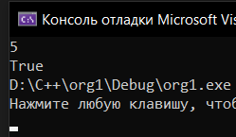 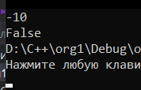

// bool2

#include<iostream>

using namespace std;

int main()

{

setlocale(LC_ALL, "Ru");

int a;

cin >> a;

if (a % 2 == 1)

{

cout << "True";

}

else

{

cout << "False";

}

}

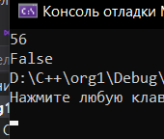 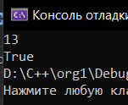

// bool3

#include<iostream>

using namespace std;

int main()

{

setlocale(LC_ALL, "Ru");

int a;

cin >> a;

if (a % 2 == 0)

{

cout << "True";

}

else

{

cout << "False";

}

}

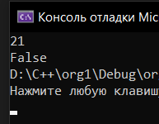 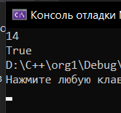

// bool4

#include<iostream>

using namespace std;

int main()

{

setlocale(LC_ALL, "Ru");

int a, b;

cin >> a >> b;

if (a > 2 && b <= 3)

{

cout << "True";

}

else

{

cout << "False";

}

}

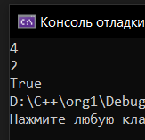 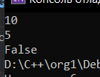

// bool5

#include<iostream>

using namespace std;

int main()

{

setlocale(LC_ALL, "Ru");

int a, b;

cin >> a >> b;

if (a >= 0 || b < -2)

{

cout << "True";

}

else

{

cout << "False";

}

}

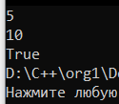 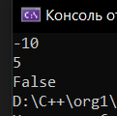

// bool6

#include<iostream>

using namespace std;

int main()

{

setlocale(LC_ALL, "Ru");

int a, b, c;

cin >> a >> b >> c;

if (a < b && b < c)

{

cout << "True";

}

else

{

cout << "False";

}

}

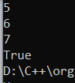 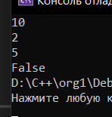

// bool7

#include<iostream>

using namespace std;

int main()

{

setlocale(LC_ALL, "Ru");

int a, b, c;

cin >> a >> b >> c;

if ((a < b && b < c) || (b < a && b > c))

{

cout << "True";

}

else

{

cout << "False";

}

}

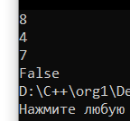 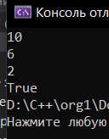

// bool8

#include<iostream>

using namespace std;

int main()

{

setlocale(LC_ALL, "Ru");

int a, b;

cin >> a >> b;

if (a % 2 == 1 && b % 2 == 1)

{

cout << "True";

}

else

{

cout << "False";

}

}

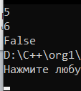 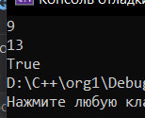

// bool9

#include<iostream>

using namespace std;

int main()

{

setlocale(LC_ALL, "Ru");

int a, b;

cin >> a >> b;

if (a % 2 == 1 || b % 2 == 1)

{

cout << "True";

}

else

{

cout << "False";

}

}

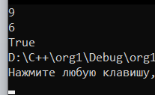 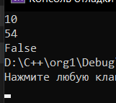

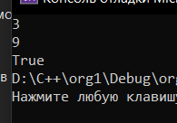

// bool10

#include<iostream>

using namespace std;

int main()

{

setlocale(LC_ALL, "Ru");

int a, b;

cin >> a >> b;

if ((a % 2 == 1 && b % 2 == 0) || (a % 2 == 0 && b % 2 == 1))

{

cout << "True";

}

else

{

cout << "False";

}

}

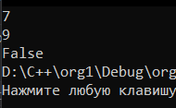 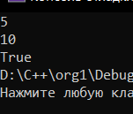

// bool11

#include<iostream>

using namespace std;

int main()

{

setlocale(LC_ALL, "Ru");

int a, b;

cin >> a >> b;

if ((a % 2 == 1 && b % 2 == 1) || (a % 2 == 0 && b % 2 == 0))

{

cout << "True";

}

else

{

cout << "False";

}

}

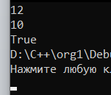 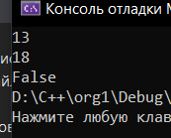

// bool12

#include<iostream>

using namespace std;

int main()

{

setlocale(LC_ALL, "Ru");

int a, b, c;

cin >> a >> b >> c;

if (a > 0 && b > 0 && c > 0)

{

cout << "True";

}

else

{

cout << "False";

}

}

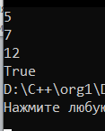 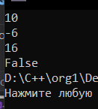

// bool13

#include<iostream>

using namespace std;

int main()

{

setlocale(LC_ALL, "Ru");

int a, b, c;

cin >> a >> b >> c;

if (a > 0 || b > 0 || c > 0)

{

cout << "True";

}

else

{

cout << "False";

}

}

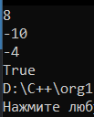 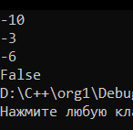

// bool14

#include<iostream>

using namespace std;

int main()

{

setlocale(LC_ALL, "Ru");

int a, b, c;

cin >> a >> b >> c;

if ((a > 0 && b < 0 && c < 0) || (a < 0 && b > 0 && c < 0) || (a < 0 && b < 0 && c > 0))

{

cout << "True";

}

else

{

cout << "False";

}

}

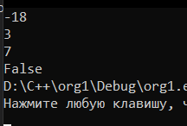 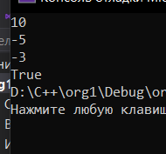

// bool15

#include<iostream>

using namespace std;

int main()

{

setlocale(LC_ALL, "Ru");

int a, b, c;

cin >> a >> b >> c;

if ((a > 0 && b > 0 && c < 0) || (a < 0 && b > 0 && c > 0) || (a > 0 && b < 0 && c > 0))

{

cout << "True";

}

else

{

cout << "False";

}

}

